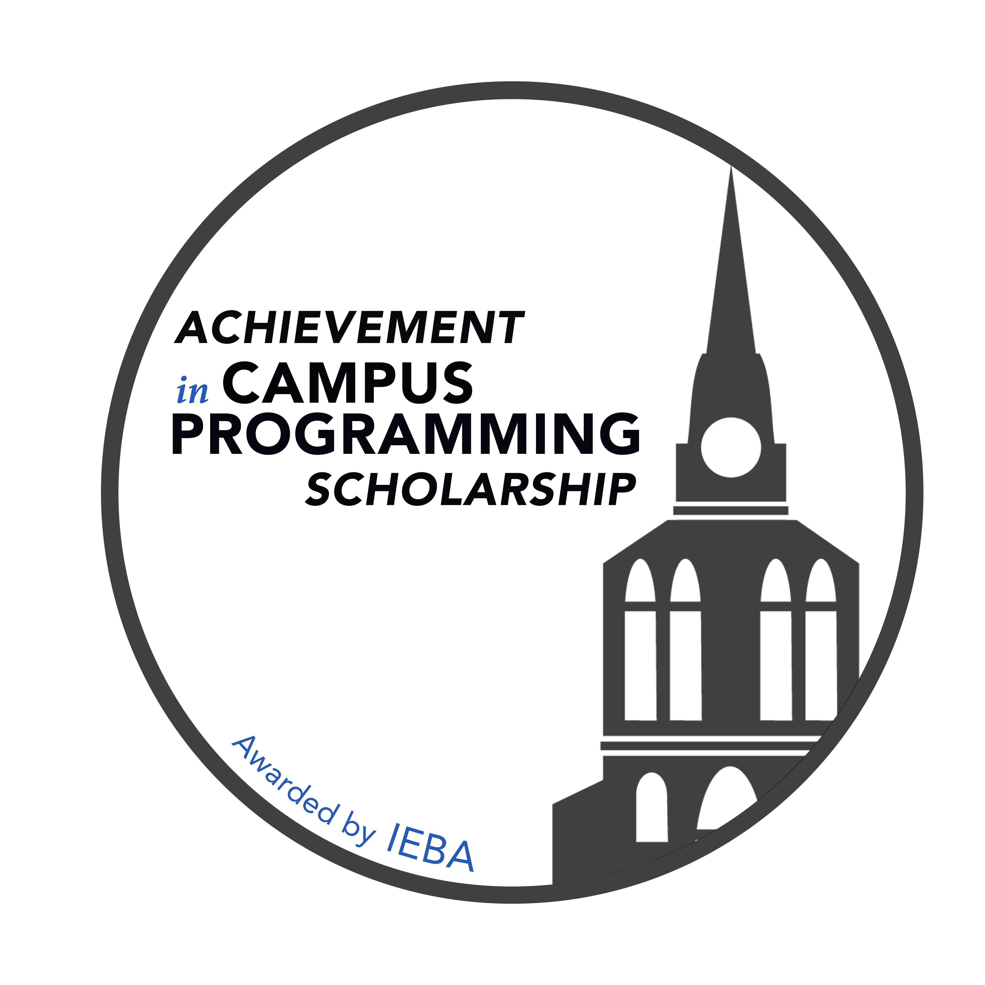
Please submit this completed application to jason@ieba.org
no later than Sunday, June 30, 2024.

2024 Winners will be notified no later than Thursday, August 1, 2024.

To apply, applicants must be enrolled as a full-time student in an accredited two or four-year college or university. Applicants must be a junior or senior during the 2024/2025 school year, with a minimum grade point average of 2.5 on a scale of 4.0.

Applicants must be actively involved in live entertainment programming on their school’s campus and hold a significant leadership position on the student activities board, campus programming board, or the like.

To be eligible for an Achievement in Campus Programming Scholarship, applicants must provide a written recommendation from 1) a live entertainment industry professional, AND 2) a professor or programming board advisor.

I, , have read and understand the above conditions of the IEBA Achievement in Campus Programming Scholarship and affirm that I meet the requirements for application. I give permission to officials of my institution to release transcripts of my academic record and other information requested for consideration for the IEBA Achievement in Campus Programming Scholarship. I understand that this application will be reviewed by IEBA staff and members of IEBA Educational Outreach Fund’s board of directors in the course of their duties. I affirm the information contained herein is true and accurate to the best of my knowledge and belief and is my own work or formally cited.

Signature ________________________________________ Date __________________________

Legal name in full (Print/type)
 | Last name | First name | M.I.
Permanent residence
 | Number, Street, and Apartment Number
 | City |  | State | ZIP
Your address
at school
 | Number, Street, and Apartment Number
 | City |  | State | ZIP

Phone | ( ) - | Email
Current College or University
2023/2024 Academic Year |  |  | Junior |  |  |  |  |  | Senior
Current Cumulative GPA |  |  |  |  |  | on a scale of
Your undergraduate major(s) or area(s)
of study
Number of college credits earned to date |  |  |  |  | Total number of credits required for graduation
Expected Graduation Date |  |  |  |  |  | Degree you will receive

List the name of your school’s student activities or campus programming organization and describe the leadership position you hold and the events the organization produces.
Name of the organization’s faculty advisor |  | Email address
 |  | Phone number | ( ) -
List college and high school activities (student government, sports, clubs, publications, school-sponsored community service programs, student-faculty committees, arts, music, etc.). List in descending order of significance.

College Activities
High School Activities

List community service activities. Do not repeat items listed previously. List in descending order of significance.

Activity Role Dates # of Weeks Active

List jobs and internships you have held in the past four years.

Type of work Employer Dates Average # of hours/week

List awards, scholarships, and special recognitions you have received. List in descending order of significance.

In one or two sentences, describe your career goals.

ESSAY
What hard skills have you developed while working with your campus activities organization? (Limit 200 words)

Instructions for Letters of Recommendation

Applicants must provide two letters of recommendation: 1) from a live entertainment industry professional, and 2) from a professor or advisor. Please follow these guidelines for letters of recommendation:

- Applicant must contact their recommenders for letters of recommendation. IEBA is not responsible for requesting recommendations.

- Recommender must send the letter of recommendation directly to IEBA. Letters received from applicants will not be accepted.

- Letters of recommendation must be received no later than Sunday, June 30, 2024.

- Recommenders can send letters of recommendation:

- By email to: jason@ieba.org
-OR-
- By mail to: IEBA
412 East Iris Dr.
Nashville, TN 37204

